
OBUA TRAINING REFERENCE
By Omega
Table of Contents

Part 1: General Information 3
Part 2: Leadership and Planning 4
- Creating Blocks 4
- Combat patrol/Recon by force/Chumming 4
- Soft/hard clearing 4
Hard clearing 4
Soft clearing 4
- Calling in support 4
- Hardpoints/Fortified positions 5
Enemy Hardpoints 5
Making your own hardpoints 5
- Motorized tactics 5
- Mechanized tactics 5
Part 3: Formations and Movement Principles 6
Part 4: Breaching and Clearing 7
- Approaching Buildings 7
- Breaching 7
Doors and Rooms 7
Stacking up 7
Split Stack 7
Single Stack 7
Pieing a door 8
Clearing rooms 8
Stairs 8
Hallways 8
Safe and Rapid Breach 8

Part 1: General Information

OBUA, or Operations in a Built Up Area, is one of the hardest and most dangerous ways of fighting and should be avoided if possible. It can lead to more fun in a mission by posing an additional challenge to your team though.

OBUA is very exhausting for players, but especially for leadership.

In OBUA it is very Important that communication is kept clear and concise, distractions are minimised, and all players remain concentrated.

Part 2: Leadership and Planning

OBUA is one of the most demanding ways of fighting. So it is very important that leaders prepare and plan beforehand so they can reduce their mental load while in battle.

Different tools can be used:

- Creating Blocks
Creating blocks is taking an OBJ or urban area and subdividing it into smaller chunks. Then numbering, naming or color coding these.
Primarily this makes the problem more manageable.
But it is also easier to task a unit to a specific area and to mention a specific area.
Further buildings inside these areas should be numbered.
It is easier to mention a specific building this way.

- Combat patrol/Recon by force/Chumming
Planning a route through an urban area and then following said route until your unit gets engaged.
If you don’t get engaged and make it to the end. Repeat on the same route, draw a new one, or, once you are sufficiently confident, call the area clear.

- Soft/hard clearing

Hard clearing
Clearing a building the “propper” way. …

Soft clearing
Clearing buildings visually from the outside and hard clearing buildings you take contact from. Reducing risk and speeding up the process.

- Calling in support
In OBUA, falling back on support available can significantly improve your team's effectiveness.
Depending on your ROE and objectives in the area you can call in CAS, armoured support, heavy weapons, and even mortars. If there is a civilian presence or a HVT to be captured you might want to choose a less destructive option. Bear in mind that relatively small calibers like a Warriors chain gun or an AT rocket can already bring down a building.
It is still in your judgement as the leader if a problem is too high of a risk on your team. So it is worth pulling back and reconsidering your approach, calling on support, or in very extreme cases going off your ROE if you AND 0 agree it is necessary.
…

- Hardpoints/Fortified positions
So called hardpoints are areas where a force is specifically positioned defensively and prepared against an enemy assault.
For Example a unit might take up positions in a large building overlooking a MSR so they can engage enemy units using said MSR.

Enemy Hardpoints
Attacking a Hardpoint is especially hard to do. Since the enemy is expecting you and prepared for your attack. …

Making your own hardpoints
When holding a position in OBUA simply holding ARD is often not sufficient. So when choosing a position keep in mind how you could repurpose parts of buildings to create your own hardpoints. For example, looking for a building with limited entrances that you can control, good sightlines in all directions, and that the building isn’t too open. So that you can take cover from incoming fire directed at your building.

- Motorized tactics
When working Motorized, ideally you won’t bring your vehicle with you. Since in OBUA the ENY AT threat is very high and Motorized vehicles usually don’t survive more than one hit from AT. It is better to leave the vehicle out of the engagement. …

- Mechanized tactics
When working Mechanized, if needed the vehicle can be brought with you. These Mechanized vehicles are usually designed to survive more than one hit from AT. So you have time to react to contact. The vehicle can also be very useful. For example as a place for the medic to treat casualties. …

Part 3: Formations and Movement Principles
Crossing roads

Staggered Column

Crossing arcs

Part 4: Breaching and Clearing
In OBUA the tactics behind breaching and clearing buildings should be known by every member of a section.

- Approaching Buildings

- Breaching

Doors and Rooms

Stacking up
Depending on how the door is located along the wall you can stack on both sides or you have to keep to one.

Split Stack
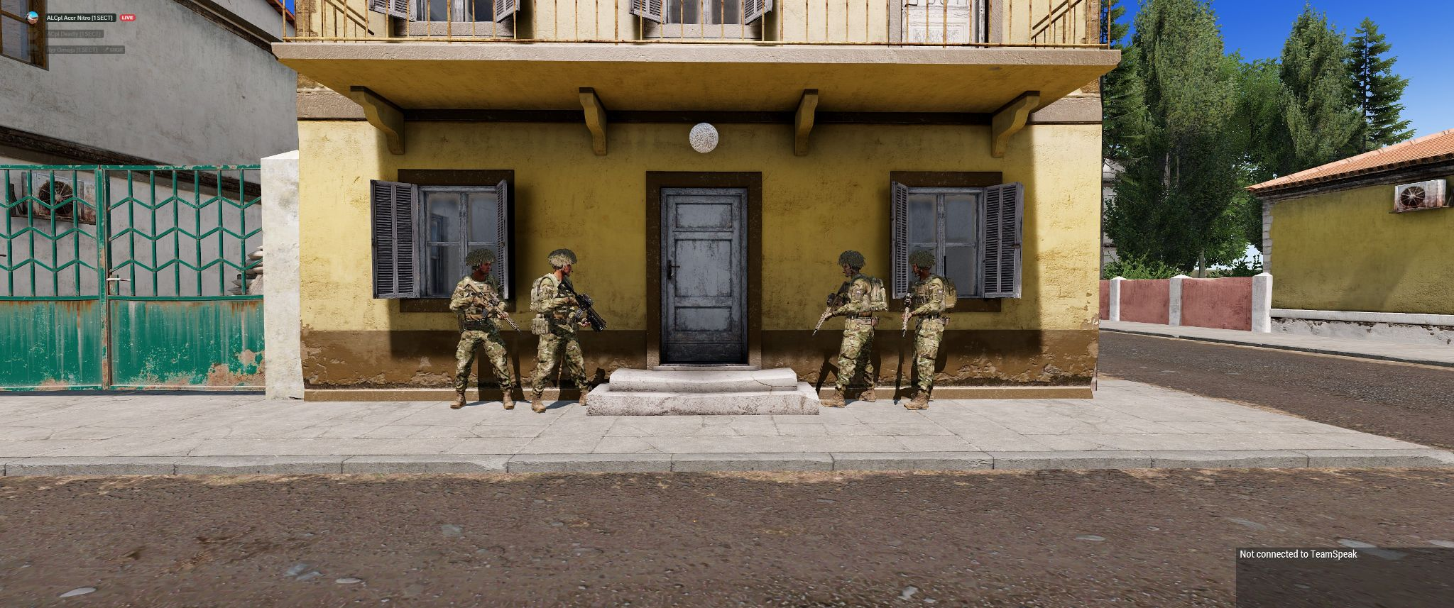
Use a split stack when there is space for minimum 2 people on either side of the door and you can move into position (i. e. the door is closed, there are no windows to be spotted from, …).

Single Stack
Use a single stack if you don't have space on the second side of the door or you can’t move there (i. e. the door is open, there is a window to get spotted from, …)
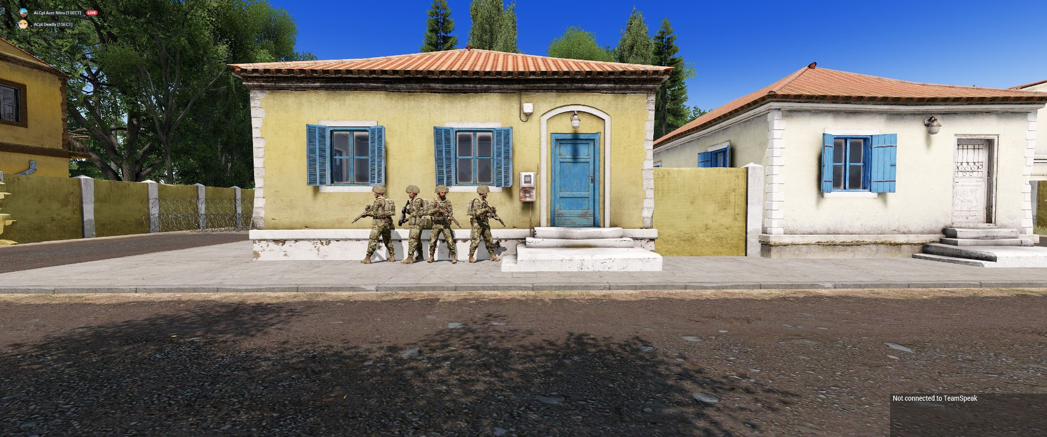

Pieing a door

Clearing rooms

Stairs

Hallways

Safe and Rapid Breach

